**V.S.B. COLLEGE OF ENGINEERING TECHNICAL CAMPUS**

**Department of Computer Science and Engineering**

**COIMBATORE**



**A Multi Media Project Report**

**On**

**Topic: “SMARTPHONE ADDICTION”**

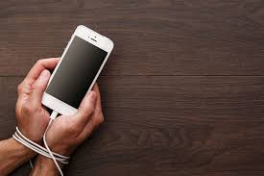

**Submitted by, Guided by,**

MANOJ PRABHU D (723715104025) Mrs. M.S. VINU

IV-CSE (AP/CSE)

**Signature of the guide**

**Introduction:**

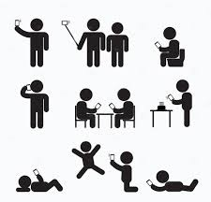**Mobile phone overuse** (**Smartphone addiction**, **mobile-phone addiction**, **problem mobile phone use**, or **mobile phone dependency**) is a [dependence syndrome](https://en.wikipedia.org/wiki/Psychological_dependence) seen among [mobile phone](https://en.wikipedia.org/wiki/Mobile_phone) users. Some mobile phone users exhibit problematic behaviors related to [substance use disorders](https://en.wikipedia.org/wiki/Substance_use_disorder). These behaviors can include preoccupation with mobile communication, excessive money or time spent on mobile phones, use of mobile phones in socially or physically inappropriate situations such as driving an automobile. Increased use can also lead to increased time on mobile communication, adverse effects on relationships, and [anxiety](https://en.wikipedia.org/wiki/Anxiety) if separated from a mobile phone or sufficient signal. Cell phone overuse has many seriously bad side effects. Primarily, they are caused by microwave radiation these devices transmit. Our immune system suffers a lot because of that. Another reason is our irresponsible use of cell phones. We strive to be constantly connected and available. This makes us feel tired, nervous, and absent-minded. We hardly realize that a reason for our fatigue is hidden in our pocket. It’s high time to discover more about the negative influence of mobile technologies.

**Effects:**

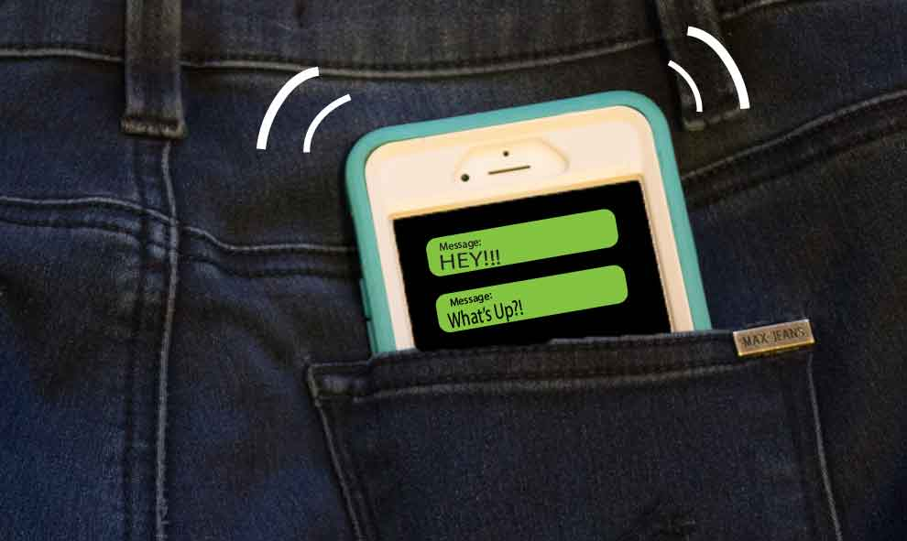**1. Phantom Pocket Vibration Syndrome**

From time to time, many of us have a feeling that our cell phone is vibrating in our bag when actually it’s not. We check it immediately and see that it was a false alarm. This phenomenon is called a phantom pocket vibration syndrome.  This especially relates to the undergraduates having a social media addiction. They are more anxious and nervous. Missing another text message feels like a real tragedy to them. Shutting a cell phone’s vibration option off is a good way to combat this syndrome.

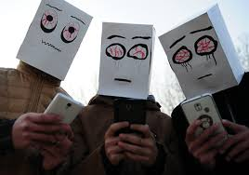**2. Blurred Vision**

When texting someone or reading an article on the Internet, we have to stare at a small-sized screen of our cell phone. That can put a lot of strain on our eyes. They can dry out and hurt when blinking. Eventually, this may result in visual deterioration. To maintain clear sight, keep your device at least 16 inches away from your face. Read extensive articles on your PC or a laptop screen only. If you currently suffer from eye discomfort, make the font size bigger on your cell phone. And don’t forget to consult an eye specialist if needed.

**3. Brain Cancer Risk**

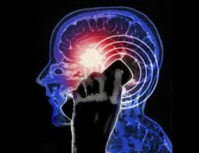Can cell phones cause cancer? In fact, there are grounds to believe it really is so. The reason for that is radiofrequency of electromagnetic fields given off by mobile devices. They have an adverse effect on our body and can trigger the development of brain cancer in the future. [According to the research](http://www.iarc.fr/en/media-centre/pr/2011/pdfs/pr208_E.pdf) conducted by the International Agency for Research on Cancer, excessive use of mobile phones may lead to the formation of such brain tumors as glioma and acoustic neuroma. First and foremost, this is an issue for those people who are virtually glued to their cell phones.

**4. Sleep Disorders**

When talking about cell phones and health, we cannot ignore their influence on sleep. Some people get used to set the alarm and put a cell phone somewhere not far from the head or even under their pillow. In fact, it’s a bad idea. As we’ve mentioned before, microwave radiation transmitted by a cell phone is harmful to a brain. Having a mobile device at hand can also end up with insomnia. You’ll feel tempted to check it at night. You won’t be able to sleep properly because of its vibrating and beeping. Sleep deprivation can lead to serious mental health problems. So make sure to turn off your cell phone or take it to another room before going to bed.

**5. Neck and Back Pain**

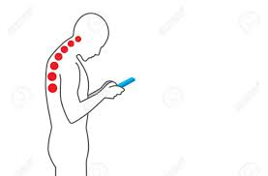A healthy spine is one of the key factors of our well-being. When slouching over a cell phone for a couple of hours per day, we ruin our neck and back muscles. So no wonder we feel the nagging pain in these parts of our bodies. But wait, there’s more. Aching neck muscles can cause a headache to make things worse. So eventually, we’ll feel like a wreck. To stay healthy, you need to watch your posture every time you use a cell phone. Sure, this may seem annoying until it becomes a habit. Turning a cell phone off or limiting the time of its usage would also relieve a spine from pressure. Remember the negative effects of cell phones on human health you’ve just read about. Use this knowledge to become a responsible mobile phone user.

**Social Media Addiction:**

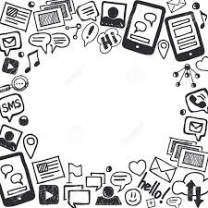Social media is addictive, that much is clear from the sharp increase year over year in how much time we spend on it. But along with the cute cat photos, amusing hash tags, likes, and favorites, we’re seeing a new form of anxiety emerge. You’ve probably come across the term FOMO (fear of missing out). It sometimes feels like the more time we spend trying to catch up online, the more we feel like we’re missing out. But it’s not just FOMO that’s got us anxious. Instead of just trying to keep up with our close friends and neighbors, we have a whole world of friends and contacts whose lives seemingly play out immediately before us. We have more digital “neighbors” than we can handle. A [new study](https://www.sciencedaily.com/releases/2016/11/161128150841.htm) shows that the kinds of comparisons we make to others online are making us more depressed than those we make offline. The problem is that we only see a tiny snapshot of people’s lives online, the highlight reel. So, while their social media walls may make it look like everyone is winning at life except you, the fact is that most of their lives never make it online.

***“At first, addiction is maintained by pleasure, but the intensity of this pleasure gradually diminishes and the addiction is then maintained by the avoidance of pain.”***

***-Frank Tallis***

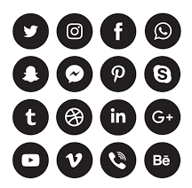Not only do we do most of our socializing online, but social media has now become a primary source of news for many people, and that takes its toll as well. Study suggests that an onslaught of violent imagery and stories about war and conflict on social media could be leading us to develop PTSD symptoms. Some [sources](http://www.rd.com/health/wellness/negative-effects-of-social-media/) even claim that social media usage can lower self control, lower self esteem, cause overeating, and prevent us from thinking independently.

**Final Words:**

***“The unfortunate thing about this world is that good habits are so much easier to give up than bad ones.”***

***-Somerset Maugham***

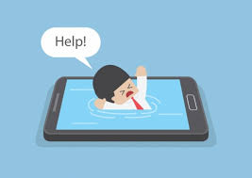

Social media is still a relatively new phenomenon, yet it already dominates significant chunks of our life. Just as with any of our other habits, we ought to examine the extent to which this habit helps or harms us. The key to keeping this part of our lives under control is, as with most things, moderation.

***“Even a happy life cannot be without a measure of darkness, and the word happy would lose its meaning if it were not balanced by sadness. It is far better take things as they come along with patience and equanimity.”***

***-Carl Jung***